SIMATS
SCENARIO-BASED ASSESSMENT REPORT
CO5 – INTEGRATED COMMUNICATION SYSTEM
FOR A SMART INDUSTRIAL CAMPUS

STUDENT NAME: LOKESH A
REGISTER NUMBER: 192512293
DEGREE: B.E. ELECTRONICS AND COMMUNICATION ENGINEERING
COURSE CODE: ECA0801
COURSE TITLE: ANALOG AND DIGITAL COMMUNICATION

SIMATS – 2026

ABSTRACT
This report develops an integrated communication architecture for a 2 km × 2 km smart industrial campus supporting up to 5,000 IoT sensors/actuators, 300 mobile users, 50 simultaneous VoIP calls and multimedia monitoring. The design combines source modelling and information measures, compression, error detection/correction, OFDMA-based access, PN spreading for selected control links, cellular resource planning, equalization and a fiber-centred network architecture.
The report makes explicit engineering assumptions where the scenario does not provide traffic concurrency, codec targets, radio propagation parameters or device battery limits. Calculations are therefore separated into specified values, stated design assumptions and illustrative analytical results. No field measurements or completed MATLAB execution are claimed. A MATLAB appendix is supplied to reproduce core information, PN and equalizer checks.

CONTENTS
- 1. Stage 1 – Interpret the Scenario Requirement
- 2. Stage 2 – Source Models, Information Measures and Compression
- 3. Stage 3 – Error Detection and Correction
- 4. Stage 4 – Multiple Access, PN Sequences and Spread Spectrum
- 5. Stage 5 – Cellular/GSM/CDMA and Equalization
- 6. Stage 6 – Integrated 5G/IoT, VoIP, DSL, Fiber, Satellite and Bluetooth
- 7. Stage 7 – Verification and Critical Evaluation
- 8. Final Deployment Decision
- 9. References
- Appendix A – MATLAB Verification Code
Note: Page numbers are generated by Word when the document is opened and updated.

STAGE 1 – INTERPRET THE SCENARIO REQUIREMENT

1.1 Scenario and traffic classification
The campus covers 4 km² (2 km × 2 km). The specified sources include sensor/actuator data, human voice, image/video monitoring and critical control messages. These sources differ in continuity, burstiness, tolerance to delay and acceptable loss.
Traffic class | Source type | Suitable source model | Primary requirement
IoT sensors | Discrete packets generated from measured physical variables | Periodic sampling plus event-driven burst model; Bernoulli event indicator | Low power, scalable access, PER ≤ 10⁻³
VoIP | Continuous speech converted to digital packets | Speech waveform sampled at 8 kHz; packet arrivals modelled as periodic 20 ms frames | One-way delay ≤ 150 ms; MOS ≥ 3.5
Image/video | Continuous visual source encoded into variable-rate packets | Frame source with variable bit rate; bursty packet process | Adequate throughput and acceptable visual quality
Critical control | Discrete command/status messages | Short-message source with priority queue and reliability target | ≥ 99% successful delivery

1.2 Information-rate implications
Rraw,IoT = 5,000 × 2 kb/s = 10 Mb/s (if every device transmits continuously)
The 10 Mb/s figure is the all-devices-active upper bound before source coding. For a planning busy-hour case, assume 10% of devices are active concurrently (500 devices), giving 1 Mb/s raw IoT load. This 10% concurrency is a design assumption, not a scenario fact.
RVoIP,PCM = 50 × 64 kb/s = 3.2 Mb/s
For video, assume 10 concurrent monitoring streams. At the specified pre-compression rate of 1 Mb/s each, the aggregate is 10 Mb/s before compression. Assuming a 2:1 practical compression ratio for planning gives 5 Mb/s. Actual codec performance depends on scene motion, resolution and quality target.
For mobile users, assume 90 of 300 users are simultaneously active (30% activity), each averaging 100 kb/s during the busy period: 9 Mb/s. This is an explicit planning assumption. The 300-user peak case must be controlled by admission and scheduling.
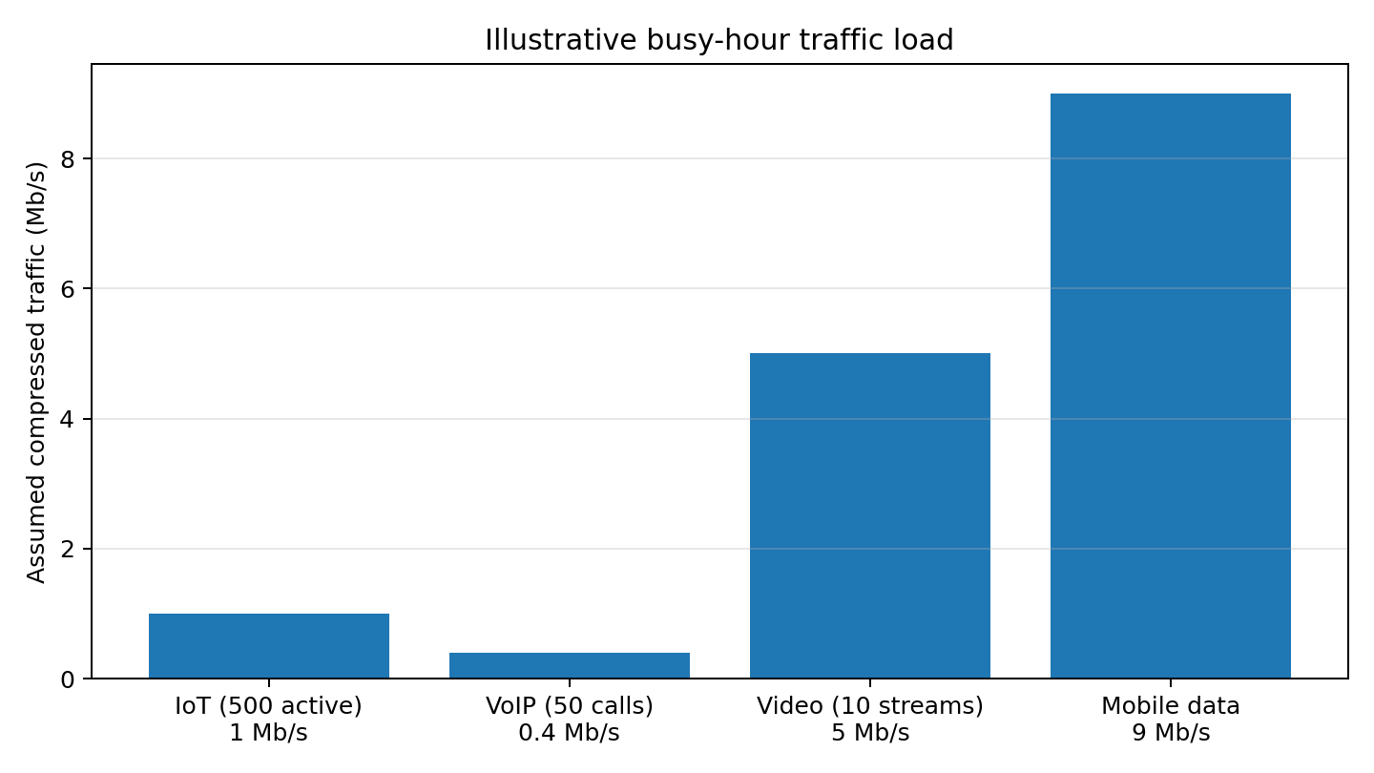
Figure 1. Illustrative busy-hour traffic load under stated concurrency and compression assumptions.

1.3 System constraints
Constraint | Scenario target | Design implication
Radio bandwidth | 20 MHz primary cellular RF | Use scheduled OFDMA resource blocks and adaptive modulation/coding
IoT reliability | PER ≤ 10⁻³ after error control | CRC detection, FEC, retries for non-real-time data; repetition/robust MCS for critical messages
Critical messages | ≥ 99% successful delivery | Priority queue, reserved resources, redundant delivery where justified
VoIP delay | ≤ 150 ms one-way | Local edge breakout, 20 ms packetization, bounded jitter buffer and QoS
Voice quality | MOS ≥ 3.5 or justified equivalent | Use a modern speech codec and monitor packet loss, jitter and delay
Multipath | Maximum delay spread 2 μs | OFDM cyclic prefix and per-subcarrier channel equalization
Backhaul | 1 Gb/s fiber | Aggregate traffic, low-latency campus core and headroom
Coverage | 2 km × 2 km | Cell planning, indoor small cells and site survey before deployment

1.4 Connectivity roles
- 5G cellular/OFDMA: primary campus-wide access for mobile users, higher-rate IoT gateways and video terminals.
- Bluetooth Low Energy: short-range sensor-to-gateway links where low data rate and low power are more important than campus-wide reach.
- Fiber: primary high-capacity connection between radio sites, edge core, control rooms and data centre.
- DSL: conditional backup for a remote building only when an existing copper access line is available.
- Satellite: emergency/remote-site backup when terrestrial fiber/DSL is unavailable; not the normal campus path because of latency and cost.

1.5 Multipath, ISI and interference
Multipath creates delayed replicas of the transmitted waveform. If delayed energy extends into the next symbol interval, inter-symbol interference (ISI) occurs. The specified maximum delay spread is 2 μs. Co-channel and inter-user interference arise when neighbouring cells or simultaneous users reuse radio resources. OFDMA scheduling, power control, frequency/time coordination, channel estimation and equalization are used together; no single technique removes all interference.

1.6 Communication System Requirement Statement
The proposed system shall provide secure, scalable and prioritized campus connectivity over a 2 km × 2 km area for up to 5,000 IoT endpoints, 300 mobile users, 50 concurrent VoIP calls and multimedia monitoring. It shall operate within 20 MHz of primary cellular spectrum, connect radio access sites through a 1 Gb/s fiber backbone, meet IoT PER ≤ 10⁻³ after error control, maintain VoIP one-way delay ≤ 150 ms and voice quality equivalent to MOS ≥ 3.5, and deliver critical control messages successfully at least 99% of the time. The design shall tolerate up to 2 μs multipath delay spread, manage co-channel interference, prioritize critical traffic, support low-power local Bluetooth links and provide justified DSL/satellite fallback paths. All unprovided concurrency and codec assumptions shall be validated during site testing.

STAGE 2 – SOURCE MODELS, INFORMATION MEASURES AND COMPRESSION

2.1 Discrete source model A – binary sensor event
Model a sensor event indicator X as Bernoulli with P(X=1)=0.1 and P(X=0)=0.9. This represents an event occurring in 10% of observation intervals. A memoryless model is a first approximation when successive intervals are sufficiently separated or event dependence is negligible. Real industrial alarms may be correlated, so stationarity and independence must be tested from logged data.
I(x) = −log₂ P(x)
H(X) = −Σ p(x)log₂p(x) = −0.9log₂0.9 − 0.1log₂0.1 = 0.469 bits/event
Self-information: I(1)=−log₂(0.1)=3.322 bits; I(0)=−log₂(0.9)=0.152 bits. The rare alarm carries more information than the common no-alarm observation.

2.2 Discrete source model B – four-symbol status source
For a representative equipment-status source, assume symbols {Normal, Warning, Fault, Maintenance} with probabilities {0.5, 0.25, 0.125, 0.125}.
H(S) = 0.5(1) + 0.25(2) + 0.125(3) + 0.125(3) = 1.75 bits/symbol
The source is treated as memoryless for the initial calculation. If status persists over time, a Markov model is more appropriate and can exploit temporal redundancy.

2.3 Block entropy and conditional entropy
For an independent and identically distributed source, block entropy is additive: H(X₁,…,Xₙ)=nH(X). For n=8 Bernoulli observations, H(X⁸)=8×0.469=3.752 bits.
To illustrate temporal correlation, assume a binary state has probability 0.9 of remaining unchanged and 0.1 of changing at each step. Its conditional entropy is H(Xₙ|Xₙ₋₁)=H_b(0.1)=0.469 bits. The lower conditional entropy compared with one bit for an equiprobable independent state indicates predictable persistence. This is an illustrative first-order Markov assumption.

2.4 Mutual information and average mutual information
Consider an equiprobable binary input sent through a binary symmetric channel (BSC) with crossover probability p=0.01. The output entropy is one bit and the conditional entropy is H_b(0.01)=0.0808 bits.
I(X;Y) = H(Y) − H(Y|X) = 1 − H_b(0.01) = 0.9192 bits/use
For a memoryless channel used independently with the same input distribution, the average mutual information per channel use is also 0.9192 bits/use. This value is an example for explaining the measure; the actual radio mutual information depends on measured SINR, modulation, coding and channel statistics.

2.5 Sampling and quantization
Source | Sampling / representation | Uncompressed rate
Voice | Band-limit speech to about 3.4 kHz; sample at 8 kHz; 8-bit PCM | 8,000 × 8 = 64 kb/s per call
Voice aggregate | 50 simultaneous PCM calls | 3.2 Mb/s
Video | Already specified as 1 Mb/s per stream before compression | 10 Mb/s for assumed 10 concurrent streams
IoT | 2 kb/s per active sensor before source coding | 10 Mb/s for all 5,000 continuously active; 1 Mb/s for assumed 500 active

2.6 Compression method comparison
Method | Best use | Compression behaviour | Limitations
JPEG | Still images and snapshots | Lossy transform coding; removes perceptually less important detail | Quality falls with stronger compression; not ideal for continuous video
MPEG family / modern inter-frame video coding | Video monitoring streams | Uses spatial and temporal redundancy between frames | Variable bit rate, codec delay and scene-dependent quality
ZIP / DEFLATE | Logs, configuration files and other lossless data | Reversible dictionary/statistical coding | Limited gain on already compressed or noisy data

Planning example: 10 video streams × 1 Mb/s = 10 Mb/s raw. At an assumed 2:1 compression ratio, the encoded aggregate is 5 Mb/s. Compression ratio = original rate/compressed rate = 2.0. This is a design estimate, not a guaranteed codec result. Critical alarm records and configuration files should use lossless compression or remain uncompressed when processing overhead is not worthwhile.

2.7 Decision 1 – modulation recommendation
I recommend adaptive OFDM/OFDMA using QPSK for robust control and weak-channel users, 16-QAM for ordinary data under moderate SINR, and 64-QAM only for users with strong channel quality because adaptive modulation balances throughput, power efficiency, occupied bandwidth and implementation complexity.
For the representative busy-hour assumptions, estimated compressed traffic is approximately 15.4 Mb/s (1 + 0.4 + 5 + 9). A 20 MHz system with a conservative net spectral efficiency of 1.5 bit/s/Hz would provide about 30 Mb/s of net capacity; at 2 bit/s/Hz it would provide about 40 Mb/s. These are planning estimates, not a guaranteed 5G throughput. Admission control is required for the 300-user all-active peak.

STAGE 3 – ERROR DETECTION AND CORRECTION

3.1 Service-specific error-control needs
Traffic | Error-control approach | Reason
Critical IoT/control | CRC-16 detection + rate-1/2 FEC (e.g. convolutional/LDPC) + bounded retransmission or repetition | Prioritizes successful delivery; CRC rejects corrupted packets
Ordinary IoT | CRC-16/CRC-24 + suitable FEC and ARQ where delay permits | Balances reliability and energy
VoIP | FEC/interleaving where needed; packet-loss concealment; avoid long ARQ | Late packets are often as harmful as lost packets
Video/multimedia | CRC + adaptive FEC/ARQ based on latency and codec layer importance | Protects important base information without excessive delay

3.2 Error detection versus correction
A checksum is simple but has weaker error-detection properties than a well-selected CRC. A CRC treats the data as a polynomial and appends the remainder after division by a generator polynomial. A block/FEC code adds structured redundancy so the receiver can correct some errors without retransmission. CRC is primarily detection; FEC is correction.

3.3 Hamming (7,4) demonstration
Use even-parity Hamming (7,4). The four data bits are 1011 and parity bits occupy positions 1, 2 and 4. The codeword is arranged as [p1 p2 d1 p4 d2 d3 d4].
Position | 1 | 2 | 3 | 4 | 5 | 6 | 7
Bit | 0 | 1 | 1 | 0 | 0 | 1 | 1
Role | p1 | p2 | d1 | p4 | d2 | d3 | d4

The transmitted codeword is 0110011. Suppose bit 6 is flipped during transmission; received word = 0110001. Parity checks produce syndrome s4s2s1 = 110₂ = 6, identifying bit position 6. Flipping that bit restores 0110011 and the original data 1011.
The code maps 4 information bits to 7 transmitted bits. Code rate R=4/7=0.5714. The redundancy overhead relative to payload is (7−4)/4×100=75%. This is suitable as a transparent classroom example, not necessarily the most efficient production code.

3.4 CRC example and checking procedure
For an illustrative CRC-8 example, choose generator polynomial G(x)=x⁸+x²+x+1 (hexadecimal 0x07). The transmitter appends eight zero bits to the message, performs modulo-2 polynomial division by G(x), and appends the 8-bit remainder. The receiver divides the complete received frame by the same generator. A zero remainder indicates no detected error; it does not prove that an error is impossible.

3.5 Coding overhead and effective rate
Rcoded = Rpayload / Rcode
For a rate-1/2 FEC code, 1 Mb/s of information requires approximately 2 Mb/s coded bit rate before framing and pilots. With an additional 5% framing/pilot overhead, the approximate physical rate becomes 2.1 Mb/s. The usable payload efficiency is 1/2.1 = 47.6%.
For a 16-bit CRC on a 256-bit payload, total packet length is 272 bits and payload efficiency is 256/272 = 94.12%, before FEC and headers. Error-control overhead must therefore be included when checking radio capacity.

3.6 Decision 2 – RF channel allocation and transmitter architecture
I recommend a centralized 5G-style OFDMA radio architecture with scheduled resource blocks, a common synchronized frequency reference, per-user power control and adaptive coding/modulation. Reserve robust low-rate resources for critical control; schedule ordinary IoT and mobile traffic dynamically; and use separate logical QoS flows for voice and video. Guard bands, RF filtering and adjacent-channel planning are finalized from the selected band plan and regulatory allocation rather than invented from the 20 MHz channel width alone.

STAGE 4 – MULTIPLE ACCESS, PN SEQUENCES AND SPREAD SPECTRUM

4.1 Multiple-access comparison
Method | Principle | Advantages | Limitations / campus suitability
FDMA | Separate frequency sub-bands per user | Simple continuous allocation | Guard bands waste spectrum; inefficient for bursty dense IoT
TDMA | Users take turns in time slots | Predictable and easy to schedule | Requires timing synchronization; idle slots waste capacity
CDMA | Users share band using distinct spreading codes | Interference averaging and soft capacity | Near-far problem; code planning and power control are essential
OFDMA | Users receive groups of orthogonal subcarriers in scheduled time-frequency blocks | High spectral efficiency, flexible scheduling, robust multipath handling with CP | Needs synchronization, channel estimation and more complex baseband

OFDMA is selected for the primary 20 MHz cellular system because the campus traffic is heterogeneous and bursty. It supports scheduling, QoS differentiation and adaptive modulation/coding. CDMA-style spreading remains useful for selected low-rate control/identification links or as a conceptual interference-management technique, but it is not selected as the main 5G air interface.

4.2 PN sequence generation using an LFSR
Use a 5-stage linear feedback shift register (LFSR), initial state 11111, with the primitive feedback polynomial x⁵+x²+1. Under the convention used in the MATLAB appendix, the output is the rightmost register bit and feedback is the XOR of the fifth and second stage. The non-zero initial state is required; the all-zero state would lock the register.
For this primitive polynomial and a non-zero state, the maximal sequence period is 2⁵−1=31 chips. The PN sequence repeats after 31 chips. The precise displayed bit ordering depends on the stated shift/output convention.
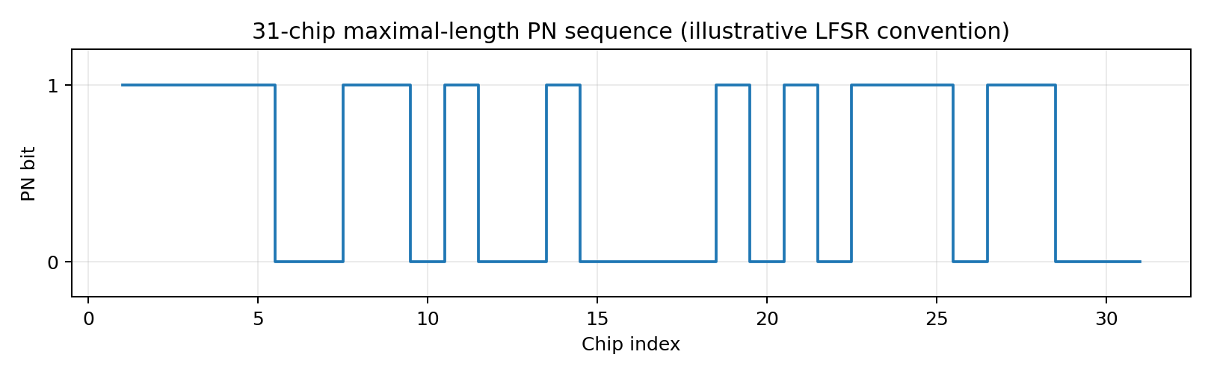
Figure 2. LFSR PN output sequence over one 31-chip period using the convention stated above.

4.3 Spreading factor and processing gain
Processing gain Gp = 10 log₁₀(N) = 10 log₁₀(31) = 14.91 dB
A spreading factor of 31 means each data symbol is represented by 31 chips. In an ideal synchronized correlation receiver, a desired code is despread while uncorrelated interference is reduced relative to the desired signal. Practical gain is lower due to imperfect synchronization, multipath, cross-correlation and near-far effects.

4.4 Spreading and despreading example
Map data bits 1,0,1 to bipolar symbols +1,−1,+1. Let the first five PN chips be c=[+1,+1,+1,+1,+1] under the chosen initial-state/output convention. The spread chip groups are [c], [−c], [c]. Despreading multiplies each received chip by the same synchronized PN chip and sums the 5 products. In the absence of noise, the sums are +5, −5 and +5; their signs recover 1,0,1.
The example illustrates correlation despreading. The production system must use a fully specified PN sequence, code assignment, timing acquisition and tracking loop.

4.5 Campus channel allocation and reuse
For a 2 km × 2 km campus, use a planned macro/small-cell overlay rather than assuming one radio site will provide uniform indoor coverage. A practical starting design is one outdoor macro or rooftop site for campus-wide mobility plus indoor small cells/access points in high-traffic buildings. Reuse the same 20 MHz carrier only where isolation and measured SINR permit; coordinate neighbouring cells with power control, resource-block coordination and antenna downtilt. Final site count and reuse geometry require a radio survey, building-loss data and regulatory band selection.

4.6 Bluetooth and satellite roles
- Bluetooth Low Energy: connect low-rate sensors to nearby industrial gateways; gateway aggregates traffic onto Ethernet/fiber or cellular backhaul.
- Satellite: provide emergency connectivity for an isolated remote utility station or temporary recovery path; it is not the normal low-latency campus control path.

4.7 Decision 3 – receiver architecture
I recommend a zero-IF/direct-conversion OFDM receiver for the primary 5G radio, with low-noise amplification, quadrature down-conversion, channel filtering, ADC, synchronization, FFT, pilot-aided channel estimation, MMSE equalization and soft demapping. It avoids a separate analog IF chain and is highly integrated, but requires careful DC-offset, I/Q-imbalance and local-oscillator-leakage calibration. A superheterodyne receiver remains an alternative where stringent blocker selectivity is more important than integration.

STAGE 5 – CELLULAR/GSM/CDMA AND EQUALIZATION

5.1 Cell and resource arrangement
The campus is divided into coverage zones based on buildings, outdoor areas and traffic hotspots. A macro layer provides mobility continuity; indoor small cells serve high-density production halls and offices. The 20 MHz carrier is centrally coordinated. Resource blocks are scheduled according to QoS class, radio quality and queue state. A site survey is required to determine the final number and placement of cells.

5.2 GSM and CDMA principles and limitations
GSM uses FDMA/TDMA with narrowband carriers and time slots, and remains relevant to legacy voice/telemetry compatibility where supported by local operators. Its fixed legacy channel structure is less flexible for the high-rate mixed traffic in this scenario. CDMA uses spreading codes and power control to separate users sharing a band; its principles explain PN sequences, correlation and near-far control. A modern 5G OFDMA system is selected as the main access method because it offers flexible time-frequency scheduling and scalable data rates.

5.3 Significance of 2 μs delay spread
A single-carrier symbol period must be compared with the channel delay spread. For example, at 1 Msymbol/s the symbol period is 1 μs, so a 2 μs delay spread spans two symbol periods and can cause severe ISI without equalization. In an OFDM system with 15 kHz subcarrier spacing, the useful symbol duration is approximately 1/15 kHz = 66.7 μs. A cyclic prefix of about 4.7 μs (normal-CP order of magnitude) exceeds the specified 2 μs maximum delay spread, so the delayed multipath energy can be contained within the guard interval, provided timing is correctly aligned.

5.4 Equalizer selection
Select pilot-aided per-subcarrier MMSE equalization for the OFDM downlink/uplink receiver. For a scalar subcarrier channel H and noise variance N₀, the MMSE coefficient is proportional to H*/(|H|²+N₀/Eₛ). Unlike zero forcing, MMSE does not attempt infinite gain in deep fades and therefore limits noise enhancement. For a frequency-selective single-carrier link, an MMSE decision-feedback equalizer may be used instead.
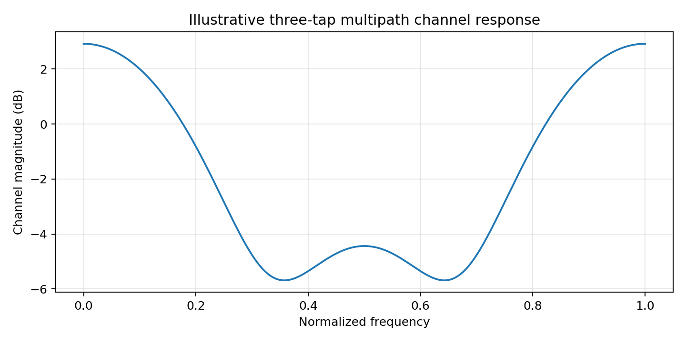
Figure 3. Magnitude response of an illustrative three-tap multipath channel h=[0.8, 0.4, 0.2].

5.5 Equalizer improvement demonstration
Use the representative discrete-time channel h[n]=[0.8, 0.4, 0.2]. The received samples are the convolution of the transmitted symbols and channel response plus noise. A linear equalizer estimates the transmitted symbol sequence from this distorted observation. ZF can invert the channel but may amplify noise near spectral nulls; MMSE balances residual ISI and noise. The MATLAB appendix generates the channel response and an illustrative equalizer comparison. Its outputs are analytical simulations to be run locally, not measured campus results.

5.6 Computational requirement
For an OFDM receiver using an N-point FFT, transform complexity is O(N log₂N). With N=1024, the order is about 10,240 complex butterfly operations per FFT (order-of-magnitude estimate). Per-subcarrier one-tap MMSE equalization then requires approximately one complex multiply and a coefficient operation per active subcarrier, far less than a long time-domain equalizer. Actual operation counts depend on FFT size, active subcarriers, channel-estimation method and implementation.

5.7 Mobility, handover and interference
- Measure reference-signal quality and trigger handover using filtered signal level/quality with hysteresis and time-to-trigger to avoid ping-pong.
- Maintain neighbour-cell lists and synchronized timing; prepare target-cell resources before handover.
- Use power control, beam/antenna configuration, scheduler coordination and interference-aware resource allocation.
- Keep critical control traffic on prioritized QoS flows and use local edge breakout to reduce core-network delay.

5.8 Decision 4
Select an indoor/outdoor cellular overlay using a centrally coordinated 20 MHz OFDMA carrier, adaptive resource allocation, mobility-aware handover and 15 kHz numerology with a cyclic prefix longer than the specified 2 μs delay spread. Use pilot-aided MMSE equalization to control noise enhancement in multipath channels.

STAGE 6 – INTEGRATED 5G/IoT, VoIP, DSL, FIBER, SATELLITE AND BLUETOOTH

6.1 End-to-end architecture
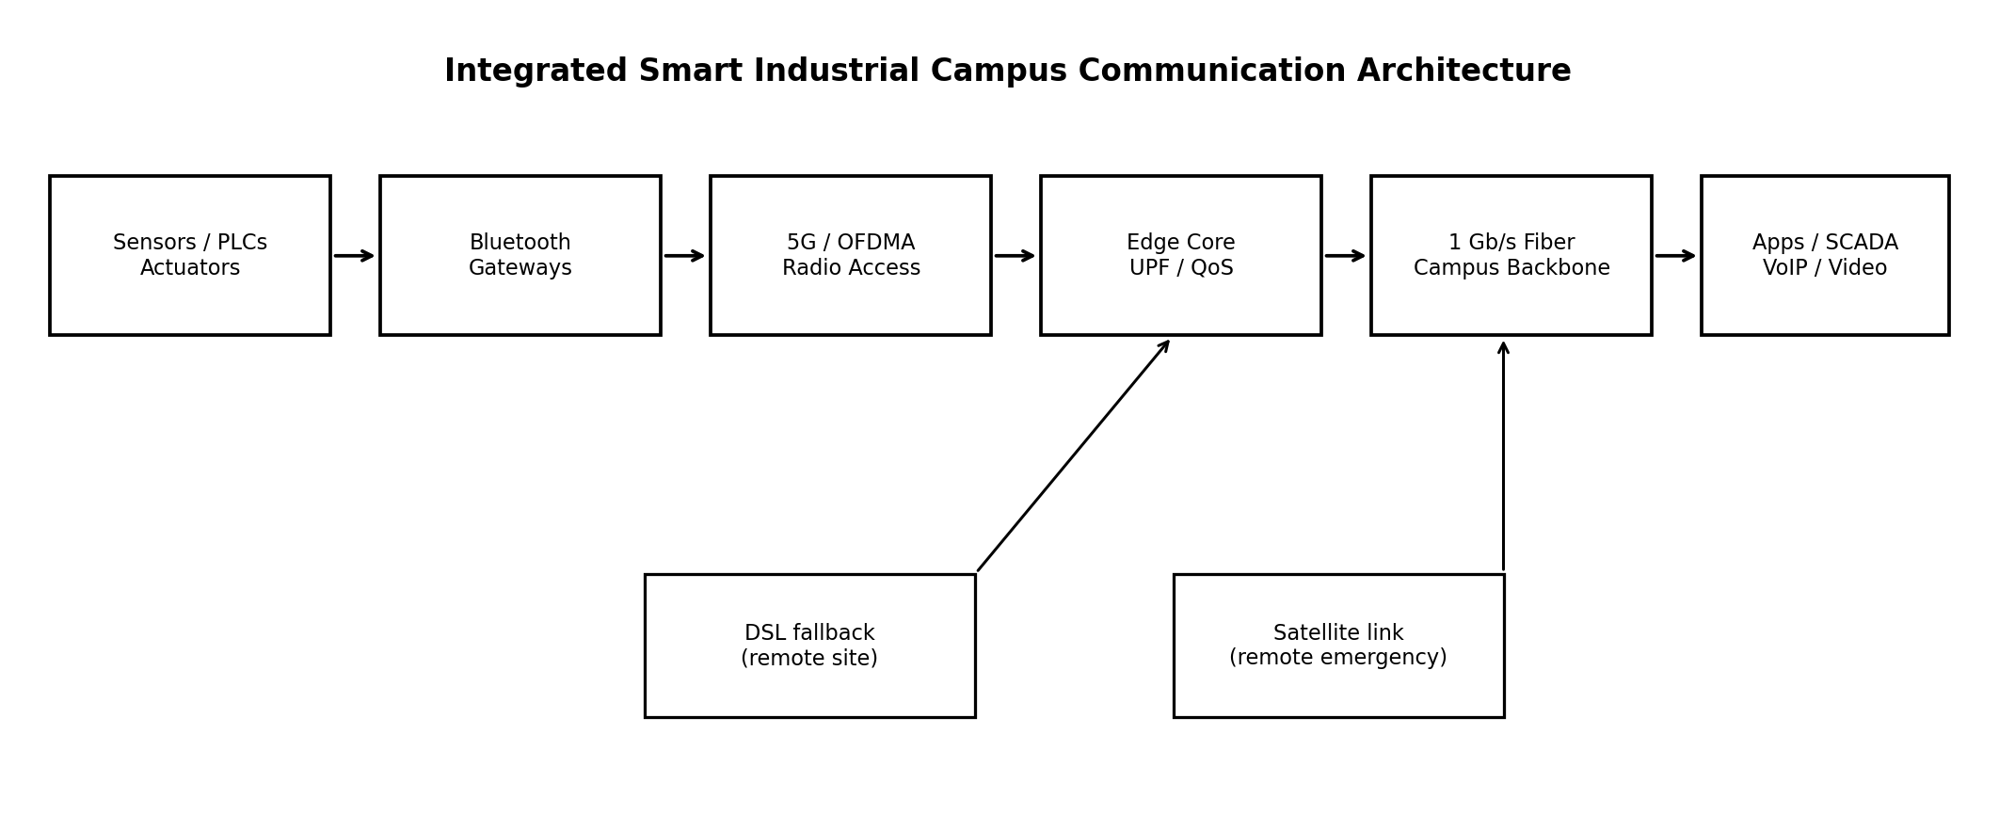
Figure 4. Proposed end-to-end smart industrial campus communication architecture.
Sensor/actuator traffic enters through direct 5G IoT access or Bluetooth gateways. The 5G radio access network transports scheduled user traffic to the edge core. The user-plane function and QoS policy route traffic onto the 1 Gb/s fiber campus backbone. Applications include SCADA, historian databases, monitoring/video servers, voice services and enterprise systems. DSL and satellite are conditional fallback links for remote or isolated sites.

6.2 Processing locations
Function | Where performed | Purpose
Source coding/compression | Sensor endpoint, camera or gateway | Reduce source bit rate while preserving required fidelity
CRC/FEC coding | Radio protocol stack / modem | Detect and correct channel errors
Spreading (where selected) | Baseband transmitter/receiver for PN-based link | Correlation processing gain for selected low-rate links
Multiple access | 5G gNB scheduler and UE modem | Allocate time-frequency resources to users
Equalization | Radio receiver baseband | Mitigate multipath and residual ISI
Decoding | Receiver protocol stack | Recover source packets and validate integrity
Application processing | Edge server / SCADA / video / voice server | Control, monitoring, storage and user services

6.3 Wireless-to-fiber interface
The gNB or access gateway connects to the campus edge/core over Ethernet optical transport. VLAN or equivalent logical segmentation separates control, IoT, voice, video and management traffic. QoS markings are mapped consistently across radio bearers and the wired backbone. The 1 Gb/s fiber provides ample nominal capacity for the illustrative busy-hour load, but redundancy, switch oversubscription and burst buffering must be engineered.

6.4 VoIP packet transport and delay budget
Use packetized voice over RTP/UDP/IP with a 20 ms packetization interval. For a compressed 8 kb/s voice codec, each 20 ms payload contains 160 bits = 20 bytes. Adding illustrative 40-byte IPv4/UDP/RTP headers and 18 bytes of Ethernet header/FCS gives 78 bytes per 20 ms, or 31.2 kb/s per call at the Ethernet frame level before preamble/inter-frame gap and link-layer details. For 50 calls, this is approximately 1.56 Mb/s.
Delay component | Planning budget
Packetization interval | 20 ms
Codec processing | 10 ms
Campus radio + transport | 20 ms
Jitter buffer | 30 ms
Decode / playout processing | 10 ms
Estimated one-way total | 90 ms

The 90 ms estimate is below the 150 ms target, leaving 60 ms margin. It is a planning budget, not a measured delay. MOS ≥ 3.5 must be confirmed using a suitable objective voice-quality metric and user testing under representative loss, jitter and load.

6.5 Fallback and traffic prioritization
Traffic class | Priority / treatment | Fallback behaviour
Critical control | Highest priority; reserved resources; robust coding; duplicate or retry where safe | Local autonomous control remains active if wide-area backhaul fails; remote link carries alarms/status
Ordinary IoT | Scheduled low-rate service; batching where latency permits | Store-and-forward at gateway; DSL/satellite only for essential summaries
VoIP | Low-latency QoS queue; bounded jitter buffer | Reduce noncritical video load; alternate route if available
Multimedia | Adaptive bitrate; lower priority than critical control | Reduce resolution/frame rate during congestion or rain/outage conditions

Bluetooth is used only for local short-range sensor connectivity to a gateway, not as a campus-wide substitute for cellular. DSL is suitable as a secondary terrestrial path where copper access exists. Satellite is reserved for remote emergency continuity because propagation delay can make it unsuitable for tight real-time control loops.

STAGE 7 – VERIFY AND CRITICALLY EVALUATE THE DESIGN

7.1 Verification method
Verification combines closed-form calculations, reproducible MATLAB checks and field acceptance tests. The assignment requires entropy, compression, PN sequence, spreading/despreading, BER/PER, access comparison, equalizer performance, VoIP delay and bandwidth utilization. This report provides analytical planning values and a MATLAB code appendix; actual measured results must be generated by running the code and then validated on the campus network.
Requirement | Specified target | Design estimate / verification method | Status
IoT packet error rate | ≤ 10⁻³ | CRC + FEC + retry/repetition; measure PER over representative fading/interference test | To be measured
VoIP one-way delay | ≤ 150 ms | 90 ms planning budget; measure one-way delay and jitter under load | Planning pass; test required
Voice quality | MOS ≥ 3.5 | Use codec quality assessment / PESQ or POLQA where licensed; confirm with listening tests | To be measured
RF bandwidth | 20 MHz | OFDMA scheduler constrained to licensed 20 MHz channel | Design fit; confirm band plan
Fiber backbone | 1 Gb/s | 1 Gb/s optical Ethernet; test throughput and failover | Design fit; test required
Critical delivery | ≥ 99% | Priority queue + FEC + retry/duplicate strategy; measure end-to-end delivery ratio | To be measured
Coverage | 2 km × 2 km | Macro/small-cell overlay; walk/drive test and indoor survey | Site survey required
ISI | Adequately mitigated | 2 μs spread < assumed ~4.7 μs CP; pilot-based MMSE equalization | Analytical fit; channel test required
Compression | Reduced rate with acceptable quality | Video assumed 2:1; measure actual codec bitrate and quality | Assumption; test required

7.2 Capacity and utilization check
Illustrative busy-hour traffic = 1 + 0.4 + 5 + 9 = 15.4 Mb/s
At an assumed net spectral efficiency of 1.5 bit/s/Hz over 20 MHz, the illustrative net radio capacity is 30 Mb/s. The busy-hour load therefore uses approximately 15.4/30 = 51.3% of that planning capacity. At 2 bit/s/Hz, estimated net capacity is 40 Mb/s and utilization is 38.5%. These estimates omit retransmission bursts, control overhead, uneven cell loading and peak-rate video; they are not a substitute for link-level simulation or a vendor capacity model.

7.3 Reliability interpretation
A PER target of 10⁻³ means no more than one packet error per thousand packets on average over the specified measurement population. Critical-message delivery ≥99% is a separate end-to-end service target and includes radio loss, congestion, gateway failure, backhaul failure and application availability. Meeting the radio PER target alone does not guarantee 99% end-to-end delivery.

7.4 Risks and mitigations
Risk | Effect | Mitigation
Indoor coverage holes | Low SINR, retries and control outages | Indoor small cells, antenna planning and RF survey
High concurrent video load | Congestion and delay for other services | Adaptive bitrate, admission control and QoS priority
Interference / near-far | Reduced throughput and packet reliability | Power control, scheduling, coordinated resources and isolation
Gateway/backhaul failure | Loss of aggregated sensor connectivity | Redundant fiber paths, local control and store-and-forward
Codec/compression variability | Traffic exceeds estimates or quality degrades | Measure actual scenes, configure rate control and retain capacity headroom
Clock/synchronization errors | OFDMA inter-carrier interference and access failures | Network timing, synchronization monitoring and robust acquisition

FINAL DECISION – WOULD YOU DEPLOY THIS SYSTEM?
DECISION: YES – CONDITIONAL PILOT DEPLOYMENT; NOT FULL PRODUCTION RELEASE YET.
The proposed architecture is technically suitable at the concept level: adaptive OFDMA provides flexible access within 20 MHz; source coding and compression reduce traffic; CRC/FEC protects packets; PN spreading is available for selected low-rate links; OFDM cyclic prefix and MMSE equalization address the specified multipath; and a 1 Gb/s fiber backbone integrates 5G/IoT, VoIP, video and campus applications.
A conditional pilot is recommended because the principal performance targets have not yet been validated with measured propagation, actual device traffic, codec behaviour, interference, mobility and failure conditions. Full deployment should proceed only after the following acceptance tests.
- Complete an RF site survey across indoor and outdoor areas and verify coverage, SINR, handover and interference.
- Run at least a representative busy-hour load test with IoT, 50 VoIP calls, mobile traffic and video streams.
- Measure IoT PER ≤ 10⁻³ and critical-message end-to-end delivery ≥ 99%, including gateway and backhaul failover.
- Verify VoIP one-way delay ≤ 150 ms and voice quality equivalent to MOS ≥ 3.5 under congestion and packet loss.
- Confirm the 20 MHz radio configuration, actual net capacity, QoS isolation and 1 Gb/s fiber redundancy.
- Validate Bluetooth gateway density and security; test DSL/satellite fallback latency and operational suitability.
If any target fails, redesign the relevant layer: add small cells or improve antennas for coverage; reserve additional control resources or strengthen FEC for reliability; reduce video bitrate or apply admission control for capacity; optimize packetization/jitter buffering for voice delay; and add redundant fiber or local autonomous control for availability.

REFERENCES
- [1] ECA08 – Analog and Digital Communication, CO5 Scenario-Based Assessment: Integrated Communication System for a Smart Industrial Campus, supplied assignment document.
- [2] C. E. Shannon, “A Mathematical Theory of Communication,” Bell System Technical Journal, vol. 27, 1948.
- [3] T. M. Cover and J. A. Thomas, Elements of Information Theory, 2nd ed., Wiley, 2006.
- [4] J. G. Proakis and M. Salehi, Digital Communications, 5th ed., McGraw-Hill, 2008.
- [5] A. Goldsmith, Wireless Communications, Cambridge University Press, 2005.
- [6] 3GPP TS 38.211, NR; Physical Channels and Modulation.
- [7] 3GPP TS 38.214, NR; Physical Layer Procedures for Data.
- [8] ITU-T G.114, One-way Transmission Time.
- [9] ITU-T G.107, The E-model: A Computational Model for Use in Transmission Planning.
- [10] Bluetooth SIG, Bluetooth Core Specification (Bluetooth Low Energy).

APPENDIX A – MATLAB VERIFICATION CODE
The following base-MATLAB script checks source entropy, a binary symmetric channel mutual-information example, a 5-stage PN sequence, spreading/despreading and a simple multipath equalizer example. It is original educational code. Run it in MATLAB and use the generated figures/command-window values as simulation outputs only after execution.
%% CO5 - Information, PN spreading and equalizer verification
clear; clc; close all; rng(7);

%% 1) Source entropy
pEvent = 0.10;
Hevent = -pEvent*log2(pEvent) - (1-pEvent)*log2(1-pEvent);
prob = [0.50 0.25 0.125 0.125];
Hstatus = -sum(prob .* log2(prob));
fprintf('Bernoulli event entropy = %.4f bits/event\n', Hevent);
fprintf('Four-state status entropy = %.4f bits/symbol\n', Hstatus);

%% 2) Mutual information of a binary symmetric channel
pError = 0.01;
Hb = -pError*log2(pError) - (1-pError)*log2(1-pError);
Ixy = 1 - Hb;
fprintf('BSC mutual information = %.4f bits/use\n', Ixy);

%% 3) 5-stage LFSR: x^5 + x^2 + 1, initial state 11111
reg = [1 1 1 1 1];
pn = zeros(1,31);
for n = 1:31
pn(n) = reg(5); % output rightmost stage
feedback = xor(reg(5),reg(2));
reg = [feedback reg(1:4)]; % shift right under stated convention
end
figure; stairs(1:31,pn,'LineWidth',1.4); grid on;
xlabel('Chip index'); ylabel('PN bit');
title('31-chip LFSR PN sequence');
fprintf('PN sequence length = %d chips; processing gain = %.2f dB\n', ...
length(pn),10*log10(length(pn)));

%% 4) Spreading and despreading
data = [1 0 1];
bipolar = 2*data - 1; % 1 -> +1, 0 -> -1
pnBipolar = 2*pn(1:5) - 1;
spread = [];
for k = 1:length(bipolar)
spread = [spread bipolar(k)*pnBipolar]; %#ok<AGROW>
end
% Ideal synchronized despreading by correlation
recovered = zeros(size(data));
for k = 1:length(data)
chips = spread((k-1)*5 + (1:5));
metric = sum(chips .* pnBipolar);
recovered(k) = metric > 0;
end
fprintf('Original data: '); fprintf('%d ',data); fprintf('\n');
fprintf('Recovered data: '); fprintf('%d ',recovered); fprintf('\n');

%% 5) Illustrative multipath channel and MMSE frequency-domain equalizer
N = 1024;
h = [0.8 0.4 0.2];
H = fft(h,N);
snrDb = 20;
noiseVar = 10^(-snrDb/10);
Wzf = 1 ./ (H + 1e-12);
Wmmse = conj(H) ./ (abs(H).^2 + noiseVar);

f = (0:N-1)/N;
figure;
plot(f,20*log10(abs(H)+1e-9),'LineWidth',1.3); grid on;
xlabel('Normalized frequency'); ylabel('Magnitude (dB)');
title('Three-tap multipath channel response');

figure;
plot(f,20*log10(abs(Wzf)+1e-9),'LineWidth',1.1); hold on;
plot(f,20*log10(abs(Wmmse)+1e-9),'LineWidth',1.1);
grid on; xlabel('Normalized frequency'); ylabel('Equalizer magnitude (dB)');
legend('ZF','MMSE'); title('ZF and MMSE equalizer responses');

fprintf('Channel taps: '); fprintf('%.2f ',h); fprintf('\n');
fprintf('Illustrative SNR = %g dB\n',snrDb);
fprintf('MMSE avoids unbounded gain in deep fades by including noise variance.\n');

%% 6) Traffic and capacity planning calculation
iotActive = 500 * 2e3; % 500 active devices, 2 kb/s each
voipCompressed = 50 * 8e3; % assumed 8 kb/s codec
videoCompressed = 10 * 0.5e6; % assumed 0.5 Mb/s per stream
mobileBusy = 90 * 100e3; % 90 active users, 100 kb/s each
totalRate = iotActive + voipCompressed + videoCompressed + mobileBusy;
netCapacity = 20e6 * 1.5; % assumed net spectral efficiency 1.5 bit/s/Hz
fprintf('Illustrative busy-hour traffic = %.2f Mb/s\n',totalRate/1e6);
fprintf('Illustrative net radio capacity = %.2f Mb/s\n',netCapacity/1e6);
fprintf('Estimated utilization = %.1f percent\n',100*totalRate/netCapacity);
Code interpretation and limitations:
- The source probabilities, traffic concurrency, video compression and net spectral efficiency are explicit illustrative assumptions.
- The LFSR bit order depends on the shift/output convention stated in the script; a standards-based deployment must document the exact polynomial, register order and code phase.
- The equalizer section plots frequency responses; it is not a full measured radio link or a field performance test.
- The code does not establish MOS, actual 5G throughput, end-to-end 99% delivery or a guaranteed PER. Those require an appropriate system-level simulator and campus measurements.

